# Team Member

Abdullah khaled Abdullah (Sec 8 ,3 Bio)

Abdullah Ahmed Abdullah Diab (Sec 9 )

Atia Nasr Atia Ahmed (Sec 8 , 3 Bio )

# Official project name: Car Parking Information System

**Project sponsor**: Ministry of transport

REKOYE

[https://www.rekoya.com](https://www.rekoya.com/)

# Project manager: Abdullah Ahmed Diab

**Project purpose**

to eliminate traffic congestion in Cairo by solving the problem Of how to provide parking spaces

# project Scope :

reduce traffic congestion in Cairo by developing a program that sends the locations of parking spaces by locating the user with cost 1 milion pound

## Product Scope Description

Product range inside Cairo

How to use: Download the program through the play store and the app store, then allow the application to access the car’s location, then walk on the map to reach the parking spot, then press “Done” when the place is not found, click on the word help, then the location will be re-sent

Product Acceptance Criteria

. make complete Data Base for Cairo city

. duration of the project not over than 230 days

. result of the project is application with easy usage

. application without errors that can make a problem to users

. android application

. IOS application

.Web application

Project Exclusions

* ***in Scope:-***
* . application without errors that can make a problem to users
* . android application
* . IOS application
* .Web application

***Out scope***

* ***Training of app users***
* ***Marketing application***

# Business case :

Eliminate traffic congestion in big cities throught an online app to report empty places nears cars and crowded roads to save time by allowing the app to access yours car location

# Constraints

* this project must be delivered within the specified budget .
* This project must be delivered on 30/12/2023
* Any laptops or computers needed must be bought from dell company

**Key deliverables**

application working on all platforms ( web, android, ios, macOS, windows)

**Project milestones**

* Requirements review : Requirements specifications are complete, correct, approved and suitable. By 30/10/2022
* Critical design review: Detailed designs fully implement the system architecture, are approved and are suitable for input into the development of code. By 15/11/2022
* System test review : The software product has passed system testing and is suitable for input into acceptance testing.by 30/11/2018
* Product operational: The software is in use in its target operational environment.by 15/12/2022

**Project resources**

* Staff : Project Manager
* App developer
* Network Engineer
* Tester
* ZenWorks Expert
* Software : Software licenses (Editors : javascript with framework node js for front end , java for back end with framework spring , using oracle for data base system ….)

**Budget**

* budget allocated for this project is 500k $

**Assumptions**

* will get all resources required.
* All important stakeholders will come to the specified meetings.
* All team members continue to the end of the project
* The App finds support from users and advertisers
* Can get investigation form companies in our project
* Don’t get over our budget

**High level risks**

* Inaccurate estimates
* Scope creep : uncontrolled changes and continuous growth of the scope or scope is ill define
* Project team misunderstanding requirments
* Loss of key personnel
* Customer will not accept the software as delivered even though it meets all specifications
* Selected technology is a poor match to the problem or customer
* Project key success criteria not clearly defined to verify the successful completion of each project phase.
* Projects within the program often need the same resources at the same time
* Do not have investigation to complete the project

**Work Breakdown Structure (WBS)**

* 1.1 DESIGN WEB APP
* 1.2 DESIGN ANDROID APP
* 1.3 DESIGN IOS APP
* 2.1 REVIEW DESIGN WEB,ANDROID APP
* 3.1 BACK-END DESIGN
* 3.2 CODING ANDROID APP
* 3.3 CODING IOS APP
* SOFTWARE DEBUG
* TESTING

# Responsibility Matrices

|  |  |  |  |  |  |
| --- | --- | --- | --- | --- | --- |
| **Task Member** | **Project Manager** | **App**  **Developer** | **Network**  **Engineer** | **Tester** | **ZenWorks Expert** |
| Create  App | A | C | P | P |  |
| Test  App | A | R | C | P |  |
| Install  Hardware | C | P |  |  |  |
| Test  Hardware | P | C | C | R |  |
| Package  App | R | C |  | A | C |
| Test App release | P |  |  | A | R |
| Push  Project to workstation | A | C |  | R | C |

## A= Approves

## R= Reviews

## P = Participant

## C = Creator

PROJECT NETWORK

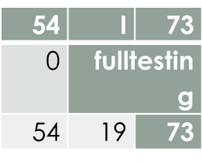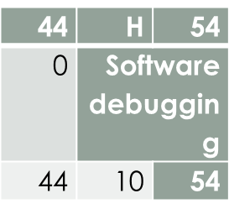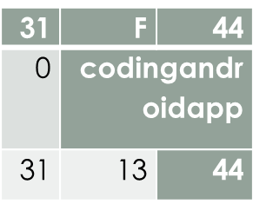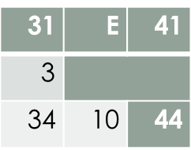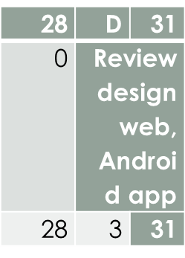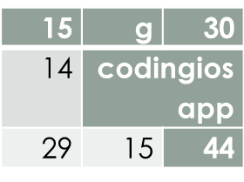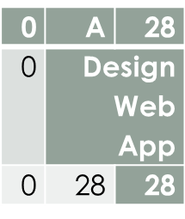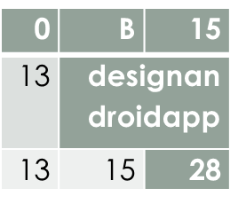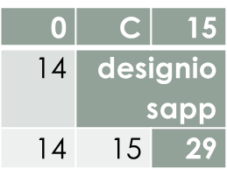EEEE

**Budget PhaseLine**

**Limit of Budget 500k $**

**1.Design : around 100k $**

**2.software :**

**-windows application about 25k $**

**-android application 25k $ at most**

**-IOS application 30k $**

**3. Database 20k $**

**Risk Management**

|  |  |  |
| --- | --- | --- |
| **Main causes** | **Sub causes** | **solutions** |
| **1-Bad timing.** | 1.1-  the time for the project was initially incorrectly calculated and set  1.2-  the project manager does not properly track employees, skills, task status  1.3-  the functional features of the final product were not determined in a timely manner; 1.4-  unexpected and urgent expansion of the project scope 1.5-  lack of resources. | ensure the maximum involvement of all team members in [planning and estimating](https://computools.com/project-estimation-techniques/), receive feedback at all stages, starting from the earliest ones, involve the Owner or Stakeholders. |
| 1. **Incorrect budget estimation.** | 2.1-  the budget was initially calculated incorrectly.  2.2-  no funds have been reserved. 2.3-  unplanned project expansion. | It is necessary to maintain constant control of the budget and development process. When introducing additional functions – or the need for any changes – calculate their cost at the discussion stage. |
| **3-poor code quality and technical risks.** | 3.1-  lack of professionalism and knowledge of team members. 3.2-  constant changes in software requirements.  3.3-  the technology used does not have a sufficient level of development and community support (it cannot provide the necessary functionality). 3.4-  too complex multi-part project. 3.5-  the implementation of project modules turned out to be more difficult than expected. | Choosing professional cadres capable of doing this task or it will not be possible to completely avoid risks –only to mitigate them. |
| **4-user engagement** | 4.1-  insufficiently deeply conducted research to identify the target audience of the project and its needs. 4.2-  incorrectly selected solution for the key needs of the target audience. 4.3-  poorly thought out, outdated, or not engaging product UX/UI design. | deep analysis of the needs of the finished product’s target audience, which is carried out by professional business analysts. This also allows taking into account certain features when developing the appearance and usability of the product. |
| 1. **Poor management** | 5.1-  poor communication and interaction within the team. 5.2-  insufficient qualification level of PM. 5.3-  lack of leadership and analytical skills. 5.4-  poor risk management in software development. | high standards are always set for the project manager. He must combine the traits and skills of a strategist and tactician, be deeply involved in the project, effectively communicate with the team, build a strong organizational framework, and implement elaborate documentation processes. |
| 1. **Poor productivity.** | 6.1-  poor project management.  6.2-  incorrectly chosen methodology.  6.3-  incorrectly matched team members. | using agile methodologies allows to maintain the productivity and motivation of all team members throughout the project since the processes are divided into shorter periods of time. |
| 1. **Unpredictable risks.** | 7.1-  sudden market changes.  7.2-  the fast growth of a competitor (with more resources available).  7.3-  implementation of new government regulations.  7.4-  changes in consumer behavior and priorities. | Hire a business analyst ,His tasks include research the market, country of operation, and worldwide tendencies to analyze the current situation. |
| **8-Inadequate Human Resources.** | Though unlikely, occasionally a stakeholder or development team member must leave a project unexpectedly. | Maintain up-to-date documentation.  On-board new or replacement stakeholders with a learning guide; and  Monitor the invoice schedule and team utilisation frequently. |